**Assignment006-3**

1. **Filters / Aesthetics / Wind**



1. **Filters / Aesthetics / Trace contour**

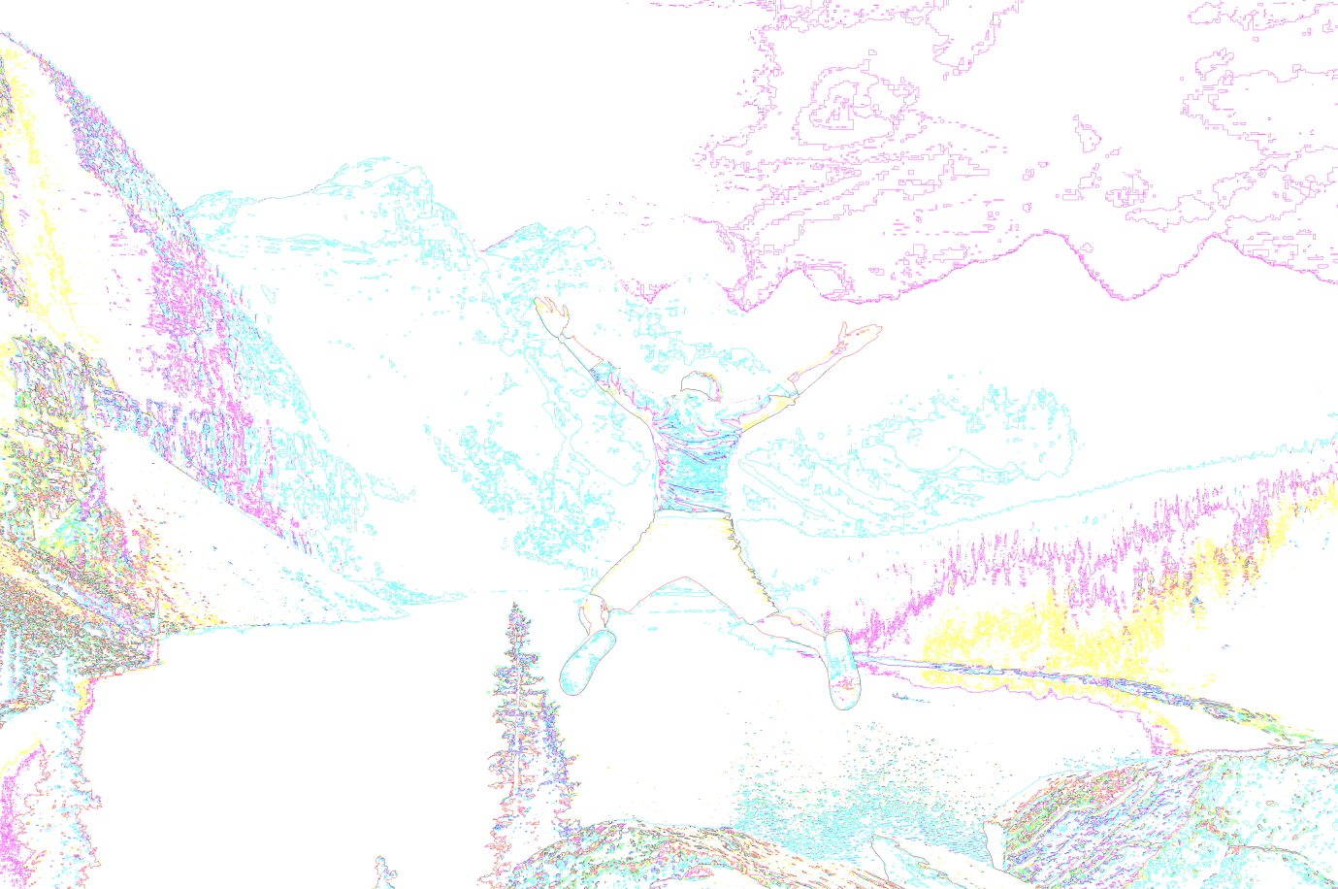

1. **Filters / Pixellisation / Crystallize**

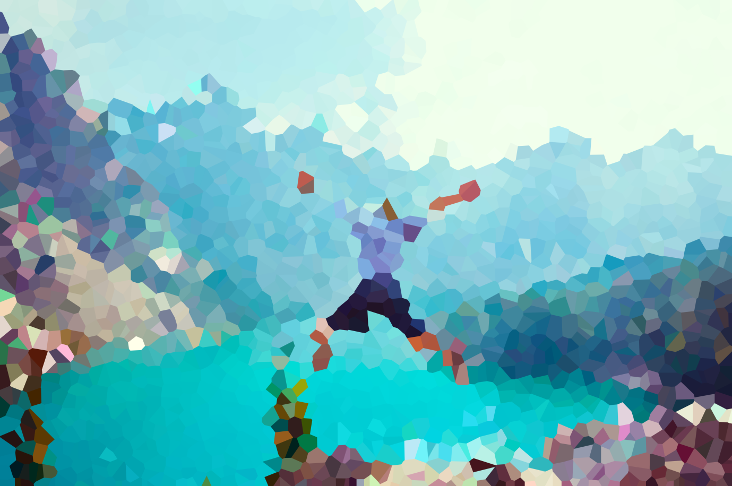

1. **Filters / Pixellisation / Color halftone**



1. **Filters / Pixellisation / Facet**



1. **Filters / Pixellisation / Fragment**



1. **Filters / Pixellisation / Mezzotint**



1. **Filters / Pixellisation / Mosaic**



1. **Filters / Pixellisation / Pointillize**

